

- 2026)
Mrs.Swathi
Saisashank.B
2520030454
CSE
CO-1 Tress & Balanced Search Structures

Case Study Topic: CivicEye Incident Monitoring using AVL Tree
Work Done Summary
In this case study, we implemented an AVL Tree for the CivicEye Smart City Incident Monitoring & Response System. The AVL Tree stores Incident IDs of traffic incidents and public complaints in balanced order to perform fast searching and insertion operations. The system automatically balances the tree after every insertion.
Implementation Details:
- Inserted Incident IDs into AVL Tree.
- Maintained balanced structure using rotations.
- Performed searching operations efficiently.
- Displayed sorted incident reports using inorder traversal.
Result: Screenshot/ Output 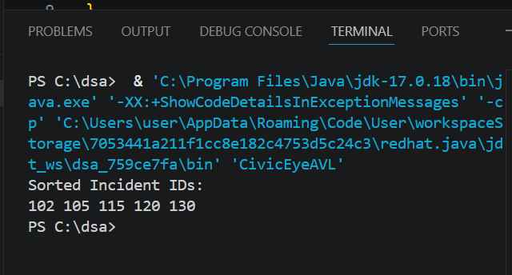
GitHub Link: https://github.com/saisashank-netizen

